Wound Up Theatre is seeking support for the professional London debut of our critically lorded, Amnesty International Freedom of Expression Award Listed play, Bismillah! An ISIS Tragicomedy, at the VAULT theatre festival 2018. A ‘Bold and Thought Provoking’ (Mark Lawson, The Guardian) piece of new writing, Bismillah! applies a compassionate and humorous approach to an incredibly important discussion about the experiences of disenfranchised youth in modern Britain. Through an intelligent yet accessible dialogue, the play examines the impact of racial, social, economic and religious politics on young people contemporary society.

About Wound Up
Wound Up Theatre is an award-winning company established in 2013 to produce social and politically aware theatre, which discusses seismic issues, through a personal, accessible and format – facilitating discussions and challenging ideas.

The company’s first play, Delusions of Adequacy explored youth unemployment through bringing to the stage a show that married - Theatre, Sitcom, Stand-up and Greek Tragedies.

More recently the company explored the impact of celebrity culture and social media on mental health through its 2017 show: #VILE: The Untimely Demise of a Manufactured Pop Star.
Established by writers Matthew Greenhough and Abee McCallum, this emerging company has already enjoyed critical acclaim for its work on the Fringe.

Bismillah!
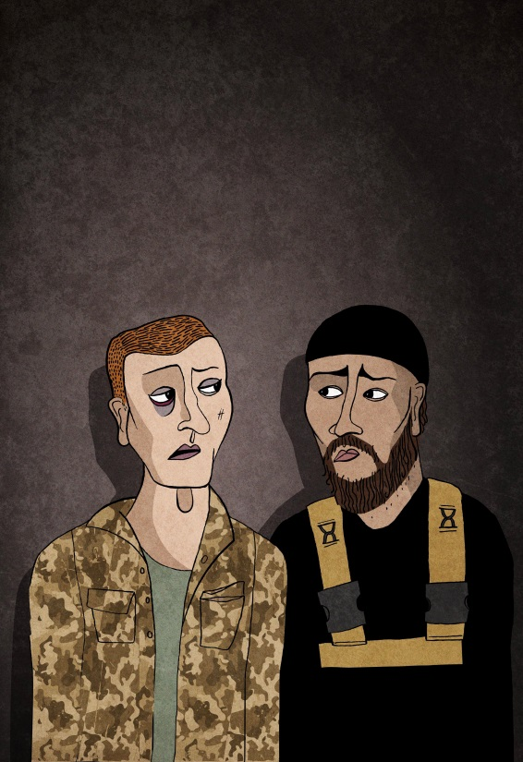
Bismillah! An ISIS Tragicomedy was the company’s second piece which debuted at the Edinburgh Fringe in 2015. The production, initially developed by Soho Theatre’s Young Writers Company, was written in response to the targeted radicalisation by extremist groups of disenfranchised young people in Britain. The play tells of the encounter between a young British prisoner of war from the North and an London born young British Muslim boy who, who has defected to join the Islamic State.

The Edinburgh production played to rave reviews, including 5 stars from Broadway Baby where the play was described as “probed informatively and with great sensitivity through the course of this dazzlingly intelligent script. Greenhough has clearly researched contemporary academic views on terrorism, so much so that the character of Danny should almost come with a citation to the work of political scientist Professor Louise Richardson. That is the intellectual level on which this show is operating... This is a fiercely intelligent, masterfully acted theatrical treat, which prompts tears of both laughter and sympathy."
Art work for Bismillah! at VAULTs Festival 2018
The show has subsequently enjoyed support and development from London’s Theatre Royal Stratford East since the Edinburgh debut. It has also been the subject of discussion and praise at Mock the Week – Comedy and the Politics of Representation, an academic conference in 2016 hosted by Teeside University, at which writer Matthew Greenhough was invited to speak.

Bismillah! has now been offered a full-length slot at the internationally renowned VAULT Festival in Waterloo and will be the companies professional London debut. The production will run from the 28th February 2018 – 4th March 2018 – but with rising venue costs and limited commercial ticketing income the only way we are able to make this emotionally provocative and politically vital story is with generous support.

Being part of a dialogue

The production has already been endorsed by Dr. Anshuman A. Mondal - Academic and author of ‘Nationalism and Post-Colonial Identity’ and ‘Young British Muslim Voices’, who has published widely on contemporary Muslim identities and cultures, nationalism, and multiculturalism. It has also enjoyed support from Nihal Arthanayake of the BBC Asian Network, and the Active Change Foundation - London’s only youth charity which focus’ on tackling radicalization in disadvantaged communities.

Bismillah! examines themes of racism (specifically Islamaphobia), disenfranchisement and radicalization and alienation in societ, while promoting a powerful message of tolerance, compassion and multiculturalism. Bismillah! is an incredibly relevant and powerful piece of theatre which tackles prevalent but often undiscussed experiences of young people in Britain.

The productions uniquely comedic approach to the subject matter, fulfils the companies ambition of creating politically charged theatre which is accessible which encourages to discussion of otherwise uncomfortable subjects. Bismillah! aims to contribute to a dialogue on the wider social implications of the issues discussed in the play, encouraging audiences to politically engage with the themes of the shows – whilst approaching the subject neutrally and from a humanist standpoint.

Fundamentally, at its heart – the show is about youth in Britain and this production aims to connect to younger audiences in an accessible and informed way. In a 2014 report published by the United Nations they discussed the fact that youth are ‘particularly vulnerable to economic shocks, social instability, and conflicts” and in this post 9/11, digitally savvy world, radicalization is a hugely complex phenomenon. Feelings of vulnerability, otherness, alienation and expert grooming techniques has led to 800 Britons going to Syria from 2012-2016 to fight for or support ISIS and a further 600 caught trying to enter.

A professional debut in London will secure critical and industry interest with the plan to tour the work nationally in 2019 – both to regional theatres and to school and community groups.

